(847 words)

Need Help with Windows 10? Try Troubleshooting
Author: Nancy DeMarte, Vice President & Education Chair, Sarasota Technology Users Group
January 2020 issue, the STUG Monitor
www.thestug.org
vp1 (at) the stug.org

Microsoft has issued updates to its operating system for as many years as it has been in the software business. Early updates were primarily security-based. Later, feature updates were included on the second Tuesdays of the month. As Windows became more complex, some updates had errors or bugs which generated complaints from its users. A recent update, 1903, was no exception. First available in May 2019, it was a large update that included new security updates and new features. Immediately, some issues showed up in areas like screen brightness, audio, missing data, and loss of Wi-Fi connection. Most home users did not have enough knowledge to fix many of these bugs. They had to wait for the next Windows update. (The current update is 1909, issued in November 2019.)
In August 2019, in response to customer suggestions, Microsoft made the 1903 download optional. Users with older computers were encouraged to wait a bit longer before installing this update. Revisions to 1903 came out often during the summer of 2019. My Update History told me that I had 10 updates to 1903 between May and September 2019.
The good news is that not only has Microsoft set up a system to fix problems more quickly, but it also has added some valuable new tools to provide help. One of them is called Troubleshoot. This is not only a helpful tool but also something that I, a moderately low-tech person, can understand and use most of the time.
How Troubleshoot works depends on the seriousness of the problem.
Critical Troubleshooting: If a computer has a “critical problem” like a computer crash, Troubleshoot will fix the problem automatically.
Recommended Troubleshooting: If you find you have a problem that is not critical, you can use Recommended Troubleshooting. Send a message to Microsoft with as many details as you have. At times, you may be asked to give feedback about your computer’s operation. Microsoft will diagnose the problem and give you suggestions for fixing it.
Data is collected from Windows computers on a regular basis. This diagnostic data can be either Basic or Full, depending on the amount of data collected. Basic diagnostic data includes information about your device and its settings, and how well it is working. This data is used to keep your device running reliably and securely. An example of Full data may include how you use your apps or websites that you visit regularly. Full data is collected from only a small number of computers. If you want to find out what data is being collected from your computer, you can download the Diagnostic Data Viewer tool. (Start > Settings > Privacy > Diagnostics & feedback.)
I had a situation that needed Troubleshoot a few months ago. I was trying out the dark mode/light mode feature (white text on a dark background or black text on a light background). At the same time, I was trying to change the color of the taskbar. (Not a smart idea) Before I knew it, I was stuck in the dark mode with a black taskbar. I sent my feedback to Microsoft and was given the steps to get out of my dilemma. To use Recommended troubleshooting, a user must have access to the Internet.
Recommended Troubleshooting has four setting options for the kind of interactions you prefer with Microsoft.
- Fix problems for me without asking
Windows will automatically run recommended troubleshooters for problems detected on your device without bothering you.
- Tell me when problems get fixed
Windows will tell you after recommended troubleshooters have solved a problem, so you know what happened.
- Ask me before fixing problems (default)
Microsoft lets you know when recommended troubleshooting is available. You can review the problem and changes before running the troubleshooter.
- Only fix critical problems for me
Windows will automatically run critical troubleshooters but won’t recommend troubleshooting for other problems. You will not get notifications for known problems, and you will need to manually troubleshoot these problems on your device.
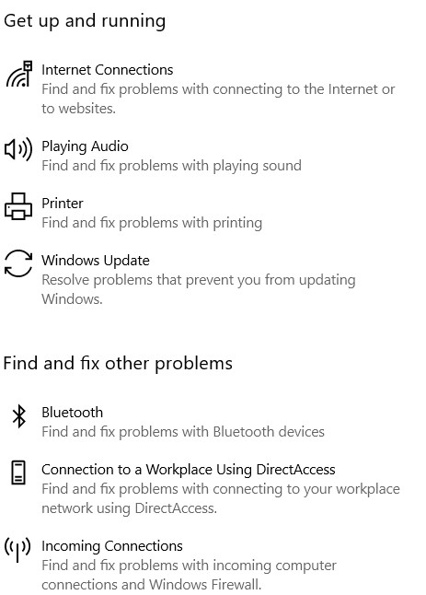
If you have Windows 10 update 1903 or 1909, you can find Troubleshoot by clicking Start (Windows key) > Settings > Update & Security. Click Troubleshoot and a list of possible problem areas will appear. (See illustration.) Select your problem area and click “Run the Troubleshooter button.”
Partial list of Windows 10 Problem areas
Troubleshoot was created to address problems more quickly than waiting for the next Windows update. But if you would rather not have data collected by Microsoft, you can disable the Recommended Troubleshoot application. Click Settings > Privacy > Diagnostic & Feedback. Select “Only fix critical problems for me.”
If you want to see what problems have been addressed on your device, you can find a list in Settings > Update & Security. Under Troubleshoot, click “View History.”
If you need more help, try the new Virtual Agent. She may be able to direct you to a solution.

